**MAKERERE UNIVERSITY**

**COLLEGE OF COMPUTING AND INFORMATION SCIENCES**

**DEPARTMENT OF COMPUTER SCIENCE**

**COURSE UNIT**: **CSC 3112: PRINCIPLES OF PROGRAMMING**

**LANGUAGES**

**LECTURER**: MADAM MARRIETTE KATARAHWEIRE

**ASSIGNMENT: II**

GROUP MEMBERSHIP

|  |  |  |  |
| --- | --- | --- | --- |
| **SN o.** | **Names** | **Registration Number** | **Signature** |
| 1 | SENYANGE RICHARD | 16/U/1102 |  |
| 2 | NAKYEWA IRENE | 16/U/851 |  |
| 3 | NINSIIMA SHEILLA | 16/U/964 |  |
| 4 | ARIHO IGNATIUS | 16/U/1811 |  |

**Cinemax theatre management system project report**

**Introduction**

Cinemax is a theatre where people go to watch movies as they relax.

Management of Cinemax theater system has been proposed to help clients assign and book seats, and sell tickets for performances wherever they are and at any time.

According to the problem that we are solving {ticket booking}, Learning about different types of languages gives us a fair idea of what kind of programming language we needed to use so as to come up with a cinemax theater program that is used for to assigning booking seats, and sell tickets for performances

**Reasons for using C language**

**Flexibility** .C is a general-purpose programming language and can efficiently work on any kind of applications depending on the problem domain.

**Library.** language has a rich library which provides a number of built in functions .it also offers dynamic memory allocation. C provides lots of functions which consist of system generated functions and user defined functions. C compiler comes with a list of header files which consist of many general functions and also allows the programmer create his own functions to complete a certain task.

**Faster** .C implements algorithms and data structures swiftly, facilitating faster computations in programs which has enabled the use of c in applications requiring higher degree of calculations like the Cinemax management system will require a lot of computation since it’s a business application.

**Procedure oriented language** is a procedure-oriented language here creates procedures or functions to execute their task which makes it easier to learn and use coz it follows an algorithm to execute statements.

It produces efficient programs.

**Steps followed to solve the problem**

**Analysis and planning of the problem**. A study was carried on the problem to determine what kind of problem domain it is and we realized the problem area was a business application since it required a lot of mathematical computation. We then analyzed what the management system is supposed to accomplish and its data inputs and outputs.

For this case, the data inputs include;

* Prices for the kind of seat one wants.
* Seat type that is the row and column of the seat needed.
* Number of seats one wants to book
* Selection of the kind of seat a client wants that is vip, vvip, ordinary etc
* Seat status which shows which seats have been booked and those that are still free.

**Data output by the system includes.**

* Seat arrangements
* The number of seats available
* Total revenue from the seats sold

**Implementation**

We generated the system requirements and drew a data flow diagram to know how the system will flow. This diagram made coding easy as the system had been broken down into modules so we were able to code each module at a time and connecting it the different modules correctly. c programming language was used to implement the system. During implementation, we included hints to direct the user on what to input since c language is a case sensitive language, entering any case of a letter wouldn’t allow the system function properly since it would be expecting the case of letter that was used declared in code.

**Testing**

Under this step, testing of the system was done to find out whether it accomplishes the tasks and conforms to the customer requirements we tested for the different errors that could be in the system and corrected them.

**Sample outputs and the system decomposition ( system flow using Flow chart)**

Using a flow chart to show the syntax of the program, below are the steps taken to we went through to solve the problem

The four major processes that are being carried out that is assigning seat, Sale, switching seats and resetting are illustrated as follows

**Assigning and selling off seat**

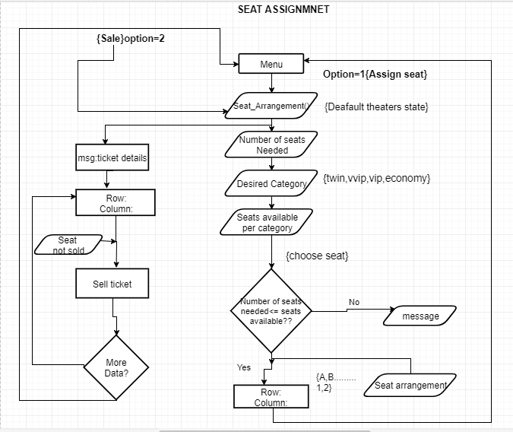

**Switching option and resetting**

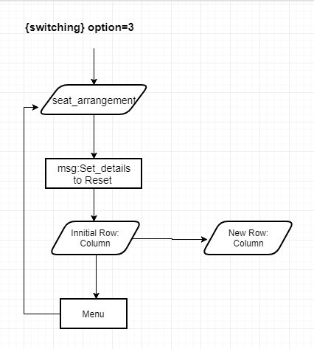 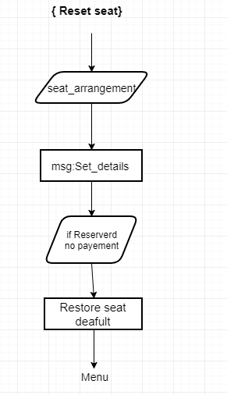

Sample outputs

Sample outputs

Booking a seat according to category

Assigning a seat

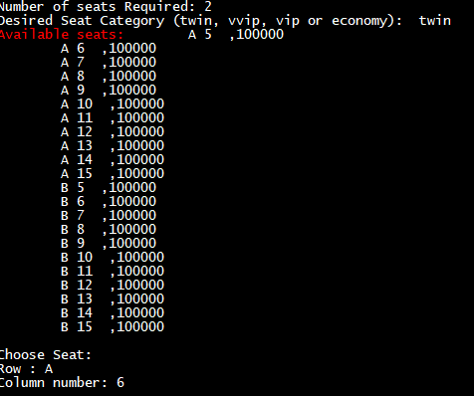

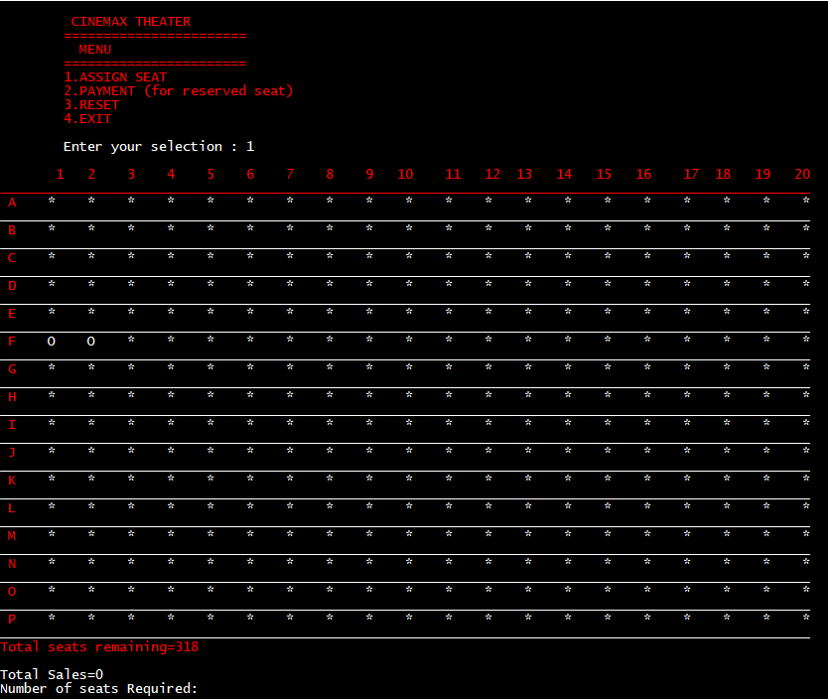

Sold off ticket A2D2,D3,D4

Booked seats A2, A3

N nn

